CRUD in MongoDB
Jeremiah (Jay) Case
SNHU
CS-340
Professor Kellogg
09/12/2026

CRUD in MongoDB
- Import the city_inspections Dataset
The city_inspections.json dataset was imported into the city database and inspections collection. The import completed successfully with 81,047 documents imported and 0 failures.
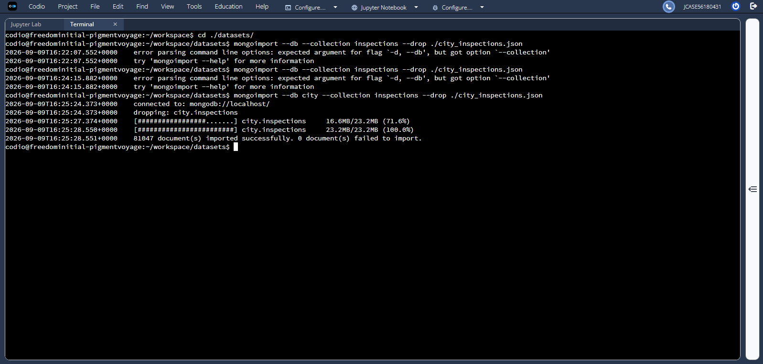

- Verify the Load – Query 1
The required query retrieved the inspection document with ID “10021-2015-ENFO”.
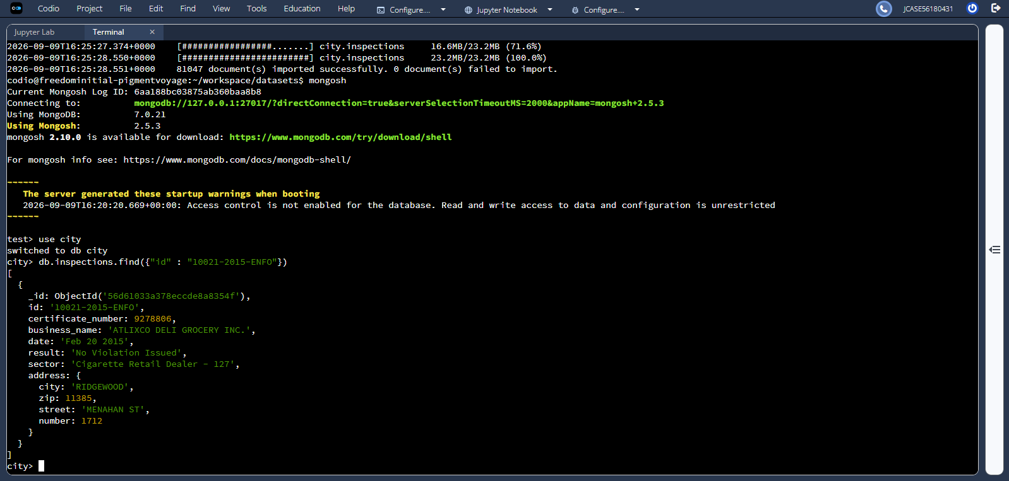

Verify the Load – Query 2
The query for the result “Out of Business” projected the business_name field and limited the output to 10 documents.
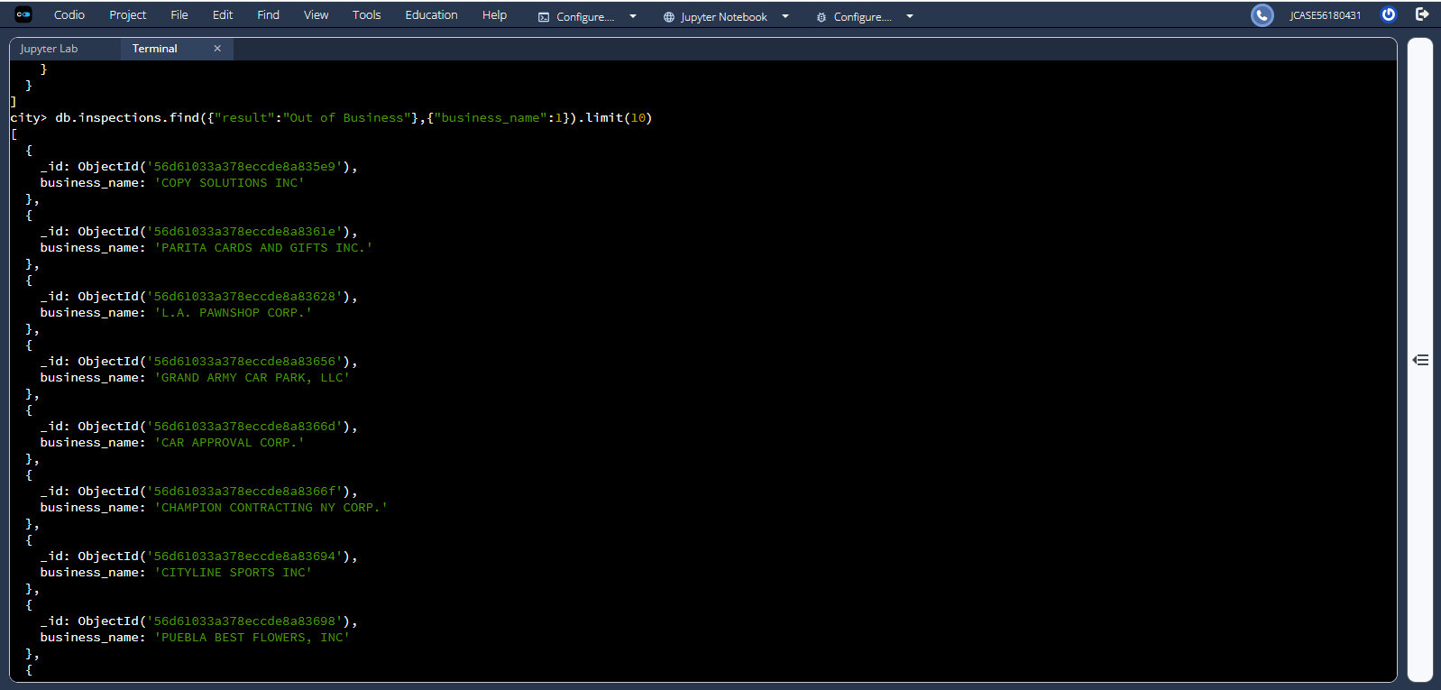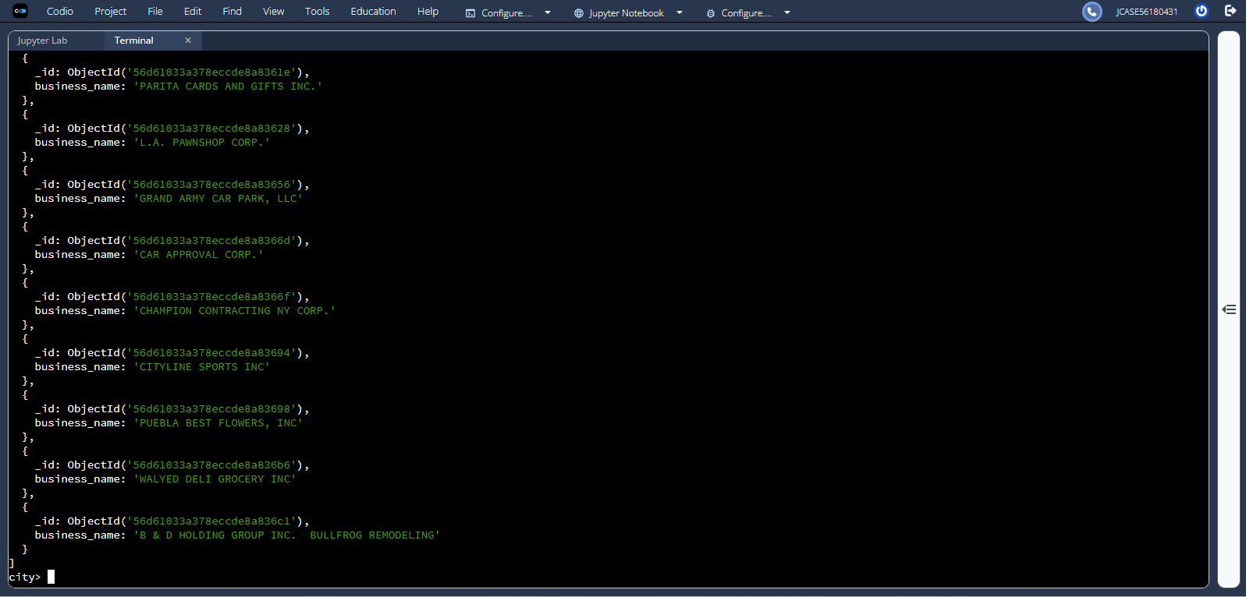

- Insert and Verify ACME Explosives
The ACME Explosives document was inserted and then verified with findOne() using the ID “20032-2020-ACME”. The address is stored as a subdocument.
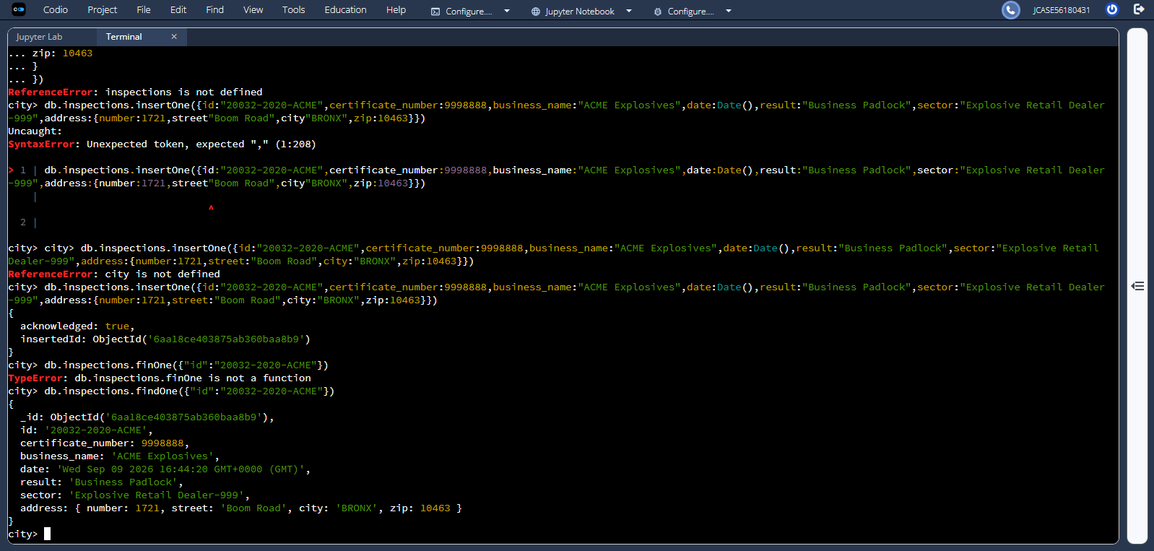

- MongoDB Query Questions
  - Distinct Inspection Sectors
The distinct(“sector”) query returned the unique sector values in the inspections collection. The number was calculated using:
db.inspections.distinct(“sector”).length
Answer
There are 87 distinct inspection sectors in the current inspections collection.
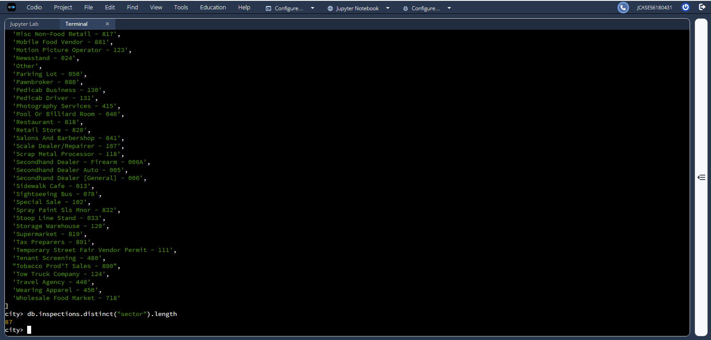

  - Date Data Type Comparison
Answer
Both AUSTIN 2012 and ACME Explosives store the date field as a string. AUSTIN 2012 uses the shorter string “Jan 22 2016”, while the ACME record created with Date() contains a longer string that includes the date, time, and time zone.
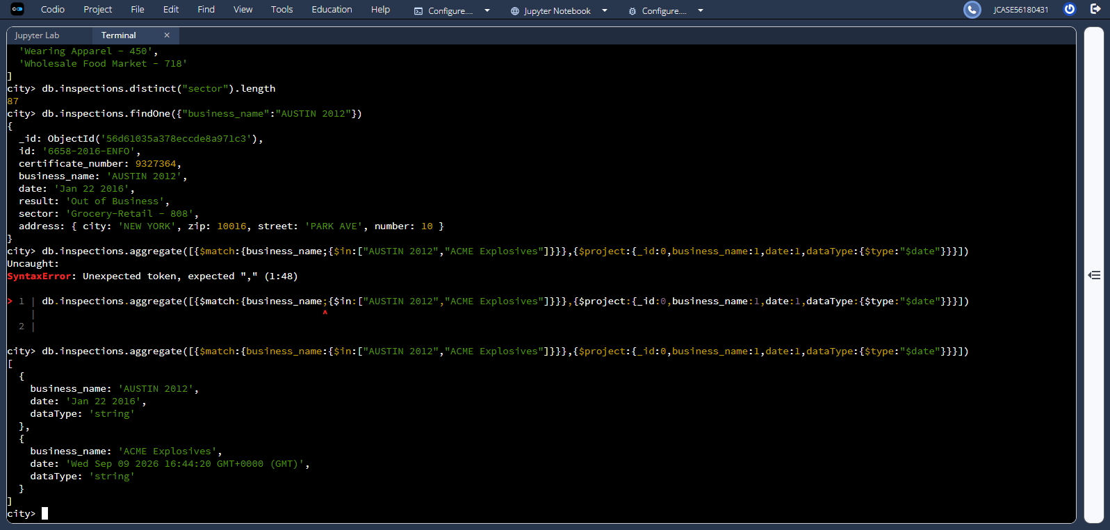

  - Violation Issued Count
The query used was: db.inspections.countDocuments({“result”:”Violation Issued”})
Answer
There were 13,823 documents with the result “Violation Issued” when the required count was performed.
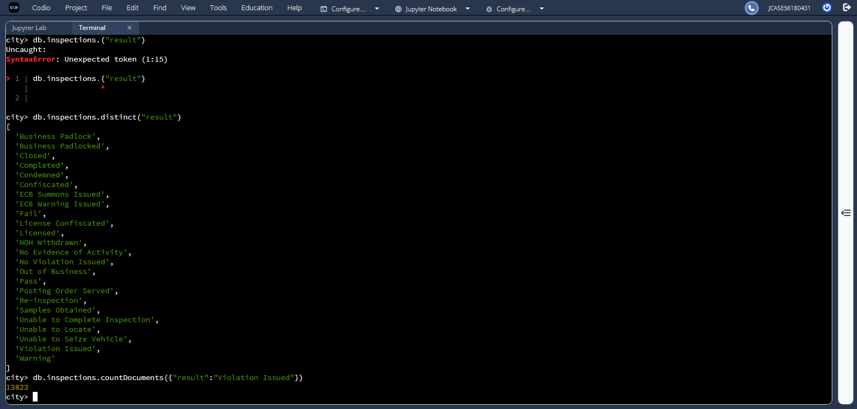

- Update the ACME Document
The document with ID “20032-2020-ACME” was updated.
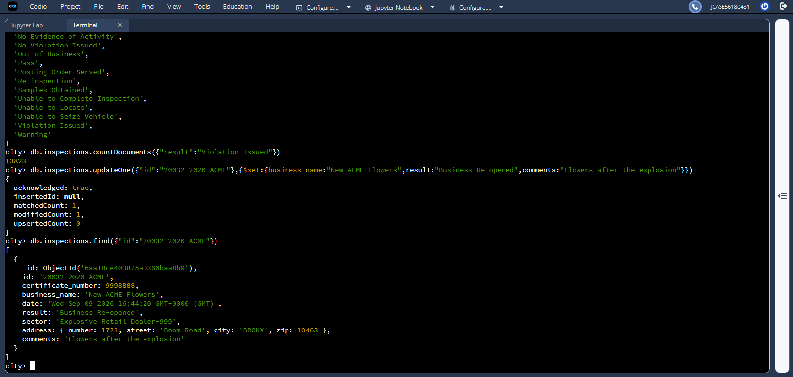
- Additional Update and Delete Operations
  - Update All ROSEDALE Documents
The updateMany() command updated all 115 documents containing “address.city”:”ROSEDALE” by changing the address.zip value to “76114”.
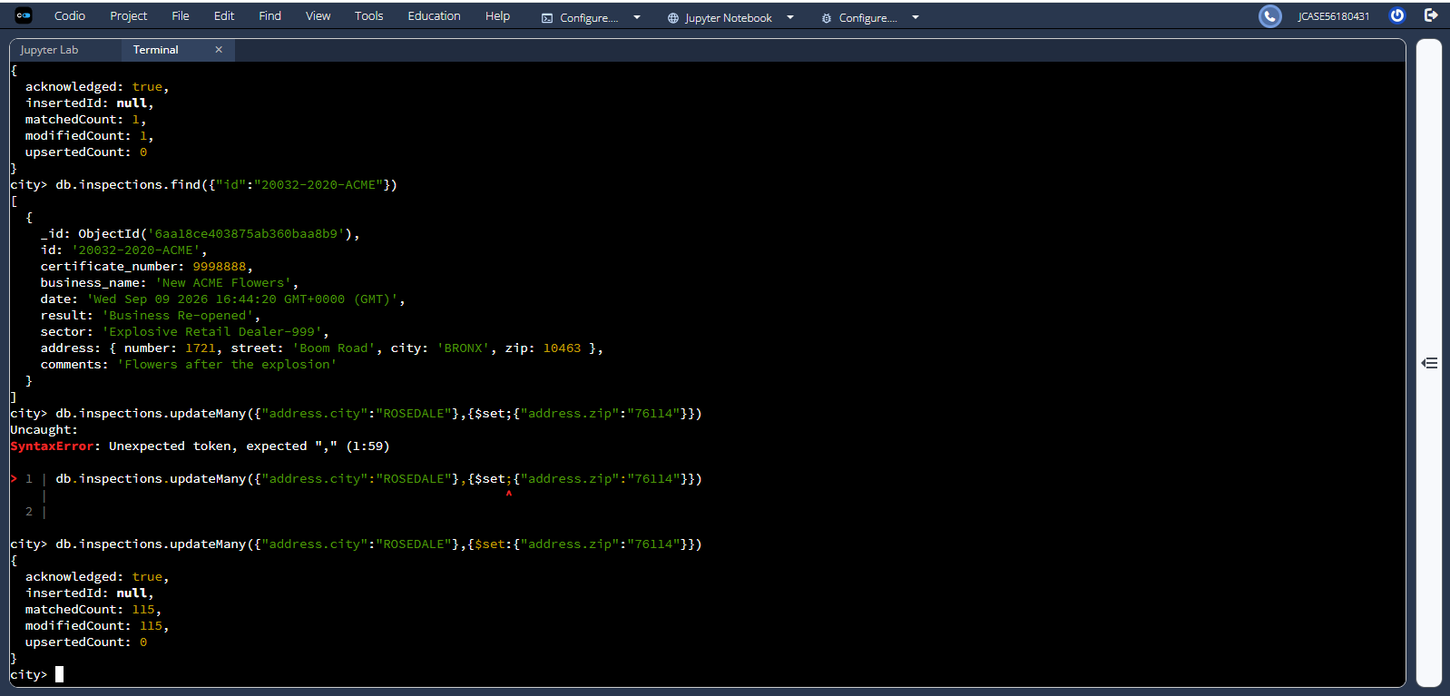
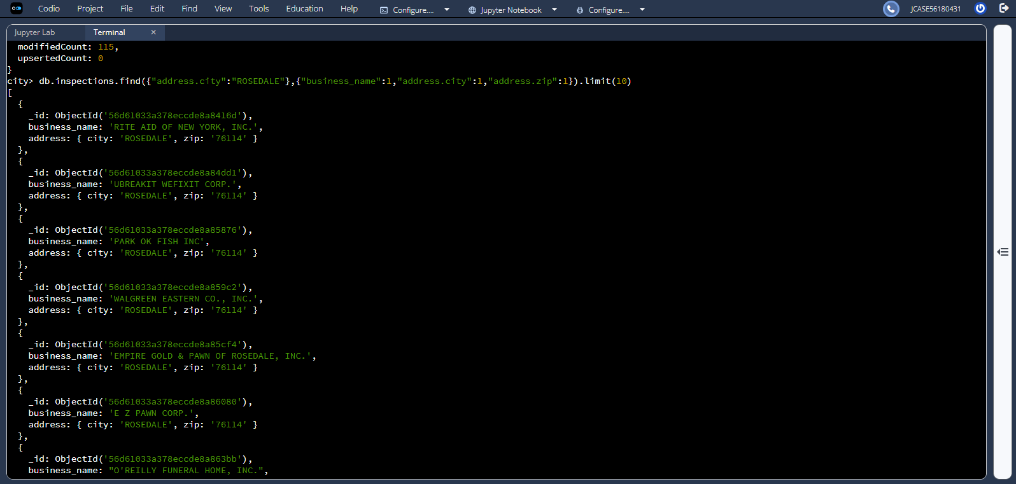
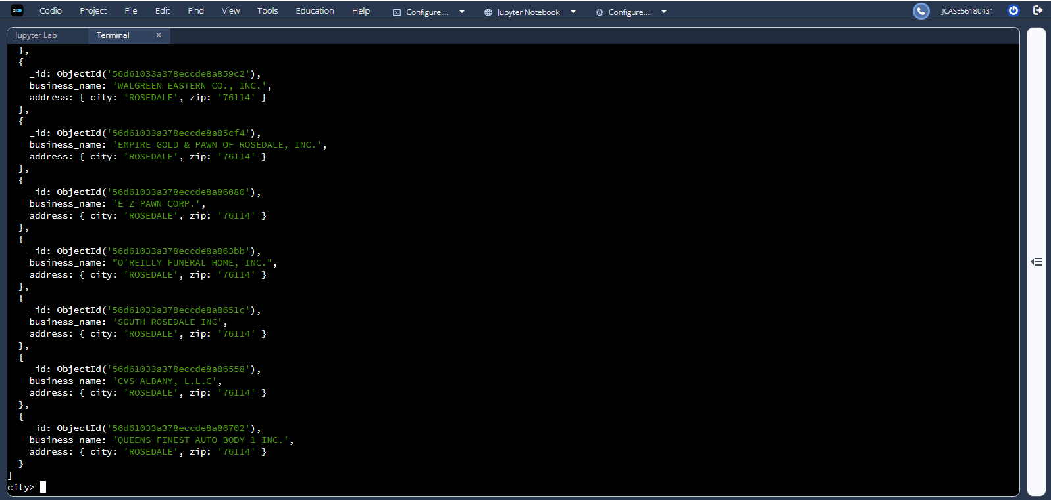

  - Delete One Violation Issued Document
The deleteOne() command removed one document with the result “Violation Issued”. The operation returned a deletedCount of 1, confirming that one document was successfully removed.
